A picture containing clipart

Description generated with very high confidence

Azure 103 Module 6

Hands on - 4

Azure Certification Training

[**support@intellipaat.com**](mailto:support@intellipaat.com)

**+91-7022374614**

**US: 1-800-216-8930(Toll Free)**

**Azure 103, Module 6, Hands On - 3**

**Problem Statement: Create a basic group and add members**

**Solution:**

**Step 1:** Sign into the [Azure portal](portal.azure.com) and search for Azure active directory in search bar, select groups from the left side menu and then click on “**New group”** option.

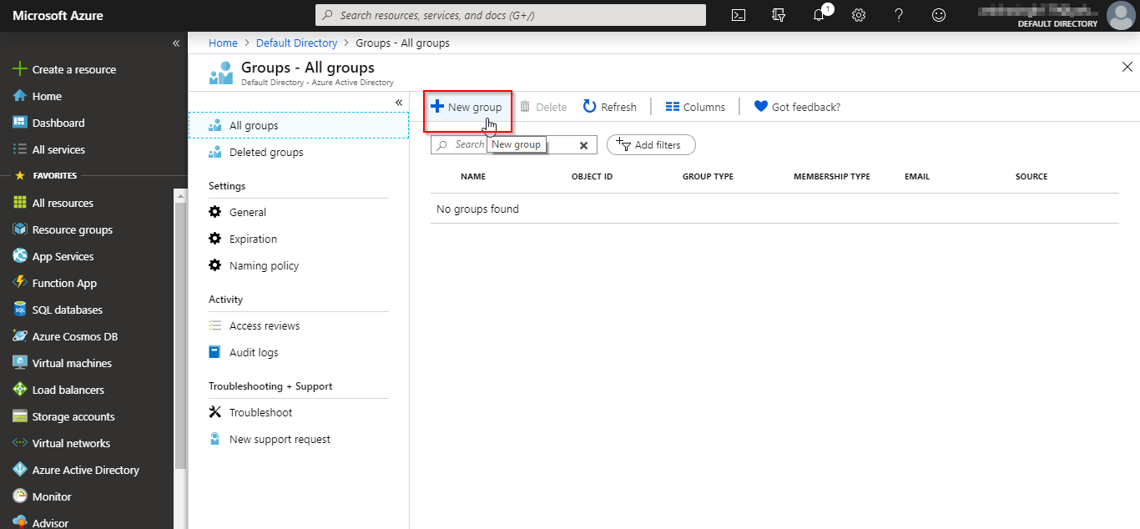

**Step 2:** Fill in all the mandatory fields then select members. Search for members in the drop down if you need. Then click on select to add the memebers.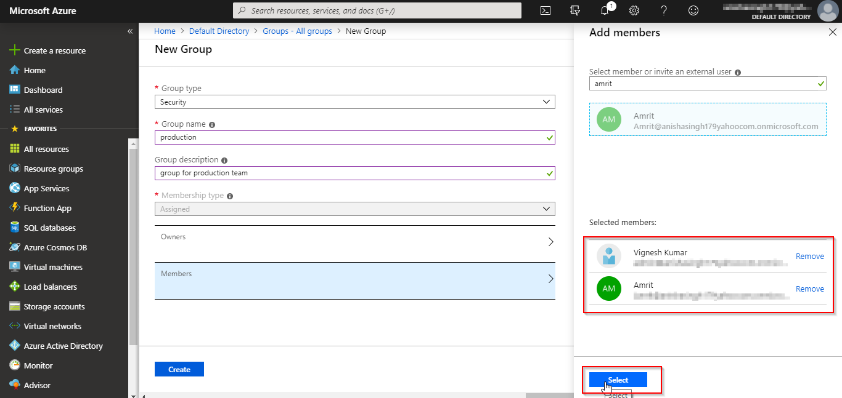

**Step 3:** Once all the information is filled, click on create to create the group.

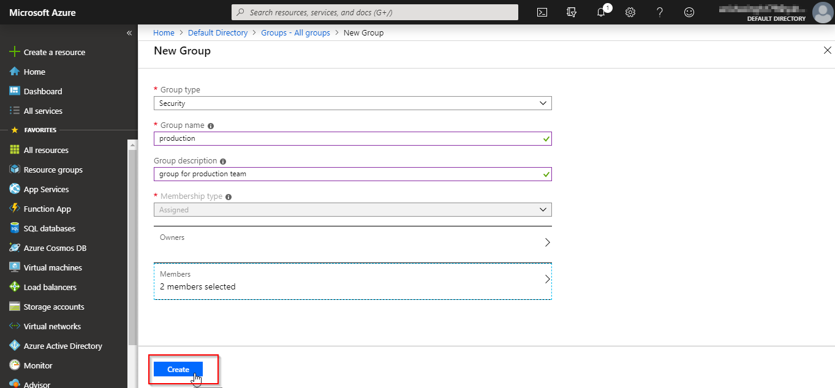

**Step 4:** The group will be created and you will be able to see it listed in the groups page.